

**STOCK PRICE PREDICTION APPLICATION USING LONG SHORT-TERM MEMORY NETWORK**

Giri Kankatharan [(gk304@kent.ac.uk](mailto:Kankatharan(gk304@kent.ac.uk))

Oliver Pulley ([ocp3@kent.ac.uk](mailto:Pulley(ocp3@kent.ac.uk))

Reece McDermott([rm782@kent.ac.uk](mailto:rm782@kent.ac.uk))

Rishabh Soni ([rs898@kent.ac.uk](mailto:rs898@kent.ac.uk))

Steven Li [(sl746@kent.ac.uk](mailto:Li(sl746@kent.ac.uk))

**Stock Price Prediction Using Long Short-Term Memory – 6000-word (excluding abstract, any appendices, and references)**

Giri [Kankatharan(gk304@kent.ac.uk](mailto:Kankatharan(gk304@kent.ac.uk))

Oliver [Pulley(ocp3@kent.ac.uk](mailto:Pulley(ocp3@kent.ac.uk))

Rishabh [Soni(rs898@kent.ac.uk](mailto:Soni(rs898@kent.ac.uk))

Steven Li ([sl746@kent.ac.uk](mailto:sl746@kent.ac.uk))

Reece McDermott([rm782@kent.ac.uk](mailto:rm782@kent.ac.uk))

# Abstract

This report illustrates the stages involved in the creation of our stock price prediction program, which lets users compare the actual prices of stocks against our algorithm predicted prices of the stocks. The program achieves this output through long short-term memory network (a type of RNN). Our report begins with an introduction, background, and goals of our program, followed by our design and implementation approach to this project. Additionally, technical processes, our problems and accomplishments surrounding this project are thoroughly analysed.

CANNOT Predict future prices of stocks

Introduction – Giri

Background - Giri

Aims – Rishabh

The primary objective of this project is to build a user-friendly application that leverages Long Short-Term Memory (LSTM) models, a type of machine learning technique, to accurately predict future stock prices. This application is designed to not only to provide reliable predictions to help users in making informed investment decisions, but also to present complex financial data in an accessible and interpretable manner. By incorporating features such as intuitive user interfaces, interactive visualizations, and natural language processing capabilities, we aim to enhance the user experience and facilitate frictionless interaction with the data. Therefore, users of varying levels of expertise can effectively navigate and utilise the platform.

# Requirements

User – Reece

Automation – Steven

Saving/Training the model* Optimal values provided* Unit Tests*

Data retrieval* Preprocessing* Prediction/Visualisation*

Design

Initial System Design - Oli

Final System Design – Rishabh or Steven

Language and Environment - Giri

* LSTM to capture patterns
  + 200 neurons because more accurate predictions + less loss
* Dropout to handle overfitting
* Dense layers to prepare for the
* Local application -> Web application

# Implementation

Long Short-Term Memory – Steven

Long Short-Term Memory (LSTM) networks are used to implement our neural network. It is a type of recurrent neural network that is designed to effectively handle and process sequential data. Since the data we use is time series data obtained from financial markets, traditional feedforward neural networks such as conventional neural networks struggle to capture patterns and temporal dependencies presented in such data due to their inability to retain information over time. This limitation is overcome using memory cells and gate mechanisms allowing them to selectively remember or forget information when required. This provides them the ability to perform pattern recognition when learning from data over a long period of time.

Our neural network relies on the implementation of these LSTM networks to make use of the sequential nature of historical stock price data. These layers are used to effectively capture patterns and trends that may influence future stock prices. The ability of LSTM networks to learn from past data, adapt to changing market conditions, and make accurate predictions make them valuable tools for analysing stock price data.

API Yahoo - Giri

Our neural network needs historical data to train and learn, to predict future prices of various stock options. We decided to use Yahoo Finance to gather closing prices of stocks because it is one of the largest rich resources of financial market data and therefore it is the best option for data collection. The larger the dataset is, the more information the neural network can learn and train itself. Yahoo Finance also provides real-time quotes and financial news however this project only focuses on predicting the closing prices of various stocks within the stock exchange.

Note: talk about the datasets

TensorFlow – Giri or Rishabh

The project extensively uses TensorFlow, an open-source machine learning framework developed by Google, for implementing and training the Long Short-Term Memory (LSTM) models. TensorFlow's versatility and scalability were vital in the making of neural network architectures for stock price prediction. Through TensorFlow's high-level APIs and computational efficiency, we were able to streamline the model development and optimise performance. Furthermore, TensorFlow's integration with GPU acceleration leads to faster training times, allowing for rapid experimentation and refinement of model architectures. TensorFlow is also open-source framework which means there is a lot of community support and documentation. This allows for extensive debugging and allows us to construct more complex models in the future.

Plotly Dash - Giri

Plotly Dash creates data visualisation and provides user interface tools for one to interact with an application/program. Regarding this project, Plotly Dash creates a dashboard for our users to interact with our program by allowing them to input the name of the desired stock then choose the start date and end date pickers for the period that you want to run the prediction for and finally, choose the number of epochs. An epoch refers to one full cycle over a training dataset for a neural network to learn patterns from the stock data. Too few epochs can result in an underfit model, whereas too many epochs can lead to an overfit one thus the default number of epochs is set to 75 however users can choose their own number of epochs. Furthermore, the larger the epochs, longer the processing time, which varies from user to user.

Exponential Moving Average (EMA) - Rishabh



Figure 1 – Equation of EMA

Where:

“EMAt “is Exponential Moving average at time t.

“α” is the smoothing factor between 0 and 1.

“EMAt-1 “is the Exponential Moving Average at the previous time step

“Pt” is the value of the data point at time t.

The Exponential Moving Average (EMA) is what is referred to as a technical indicator in financial analysis, particularly for stock market prediction. Unlike simple moving averages (SMA) that give equal weight to all data points within a specified period, EMA assigns exponentially decreasing weights to older data points, with more recent data points carrying greater weight. This feature makes EMA more responsive to recent price changes and enables it to capture short-term trends effectively leading to less "lag" compared to standard moving average allowing it to closely fit the price. Within our stock prediction application, EMA is incorporated into the preprocessing stage of data preparation. By calculating EMA values for historical stock prices, we provide additional insights into the underlying trend of the stock's price movements. These EMA values are then used as features alongside other relevant data points in training our predictive models. The primary benefit of EMA is its responsiveness to recent price changes, allowing it to adapt quickly to evolving market conditions. However, it is important to note that EMA, like any technical indicator, is sensitive to market noise and may produce false signals, especially in volatile markets.

Validation Over Loss Graph – Oliver

Historical Volatility Visualisation – Rishabh

 Figure 2- Historical volatility section

Where:

* Standard Deviation of Returns: This is the standard deviation of the stock's daily returns over a specified period.
* Number of Trading Periods in a Year: Typically, this is set to the square root of the number of trading days in a year (252 in the U.S. Market)

The Historical Volatility Visualisation is an important tool for investors and traders seeking to gauge the risk associated with specific stocks. By plotting historical volatility over time, users can observe the magnitude and frequency of price fluctuations, providing valuable insights into market dynamics. For instance, during periods of high volatility investors may opt for defensive strategies to mitigate risk, such as diversification. Whereas, periods of low volatility show stability in the market, presenting opportunities for trend-following or momentum strategies. It is calculated by determining the annualized standard deviation of the daily change in price.

Real-time stock prediction – Giri

ChatGPT integration – Steven, Rishabh and Giri (Generative AI) – Transformer Model

In our project, we’ve integrated the GPT model of OpenAI as a core component of our chat interface, enhancing the user experience and providing intelligence responses to queries. The GPT model, access through the OpenAI API

Neural network Training (RNN Network) - Steven or Rishabh

Simulator/Interface

Simulator or the user interface results

More about the training then the network ig? How you trained/saved models. The use of TANH and RELU, why we chose what layers, what layers do. Ig the stuff we explained to giri before > Leave this here so we can use as prompt*

Testing – Oliver and Steven

<UNIT TESTING>

We need a detailed report of testing and training in the corpus

Conclusion - Oliver

Future Work – Oliver

Maybe use django framework for a more complex website

Add portfolios

Add social networking

Integration with Trading Platforms

Acknowledgements – Reece

Bibliography

[Is Yahoo Finance Reliable? Exploring the Pros, Cons and Risks of Using Yahoo Finance for Investment Research - The Enlightened Mindset (tffn.net)](https://www.tffn.net/is-yahoo-finance-reliable/)

[Epoch Definition | DeepAI](https://deepai.org/machine-learning-glossary-and-terms/epoch)

<https://www.sciencedirect.com/topics/computer-science/long-short-term-memory-network#:~:text=Long%20short-term%20memory%20(LSTM,prevent%20this%20problem%20during%20training.>

**Appendices**

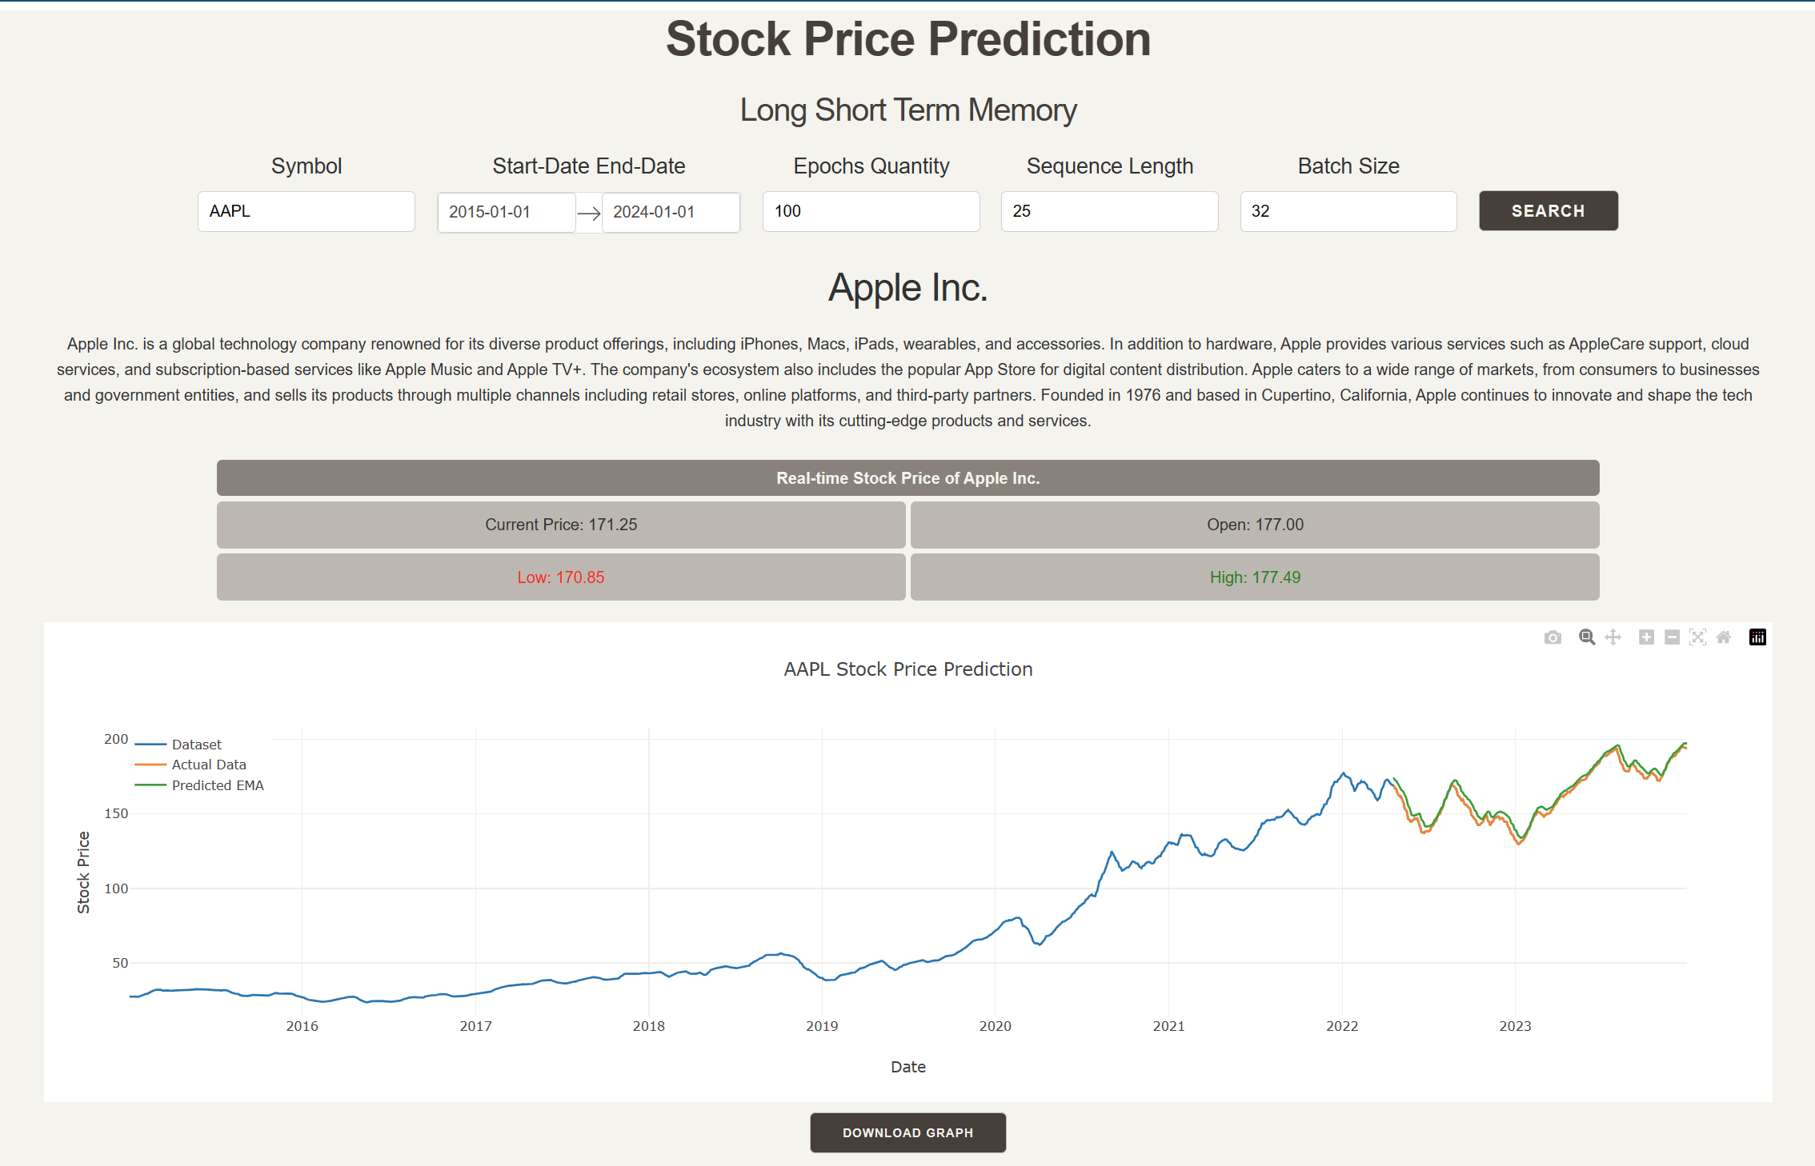

Figure 1 – Stock description

Figure 2 – Actual price of stocks vs Predicted stock price using LSTM

Figure 3 – Real-time stock information for the current period

Figure 3 – ChatGPT

Figure 4 -

Challenges

Using Dash integrating